MITRE ATT&CK 101 – A Practical Guide
Introduction
Cybersecurity teams need a common way to understand how attackers operate. Different threat actors may use different tools and malware, but their activities can often be described using common attacker behaviors.
MITRE ATT&CK is a globally used knowledge base that organizes known adversary behaviors. It helps security teams understand, document, detect, and respond to cyber threats.
ATT&CK stands for Adversarial Tactics, Techniques, and Common Knowledge.
The framework provides a structured way to describe an attack from the attacker's point of view. It includes tactics, techniques, and sub-techniques that represent different stages and methods of adversary activity.

1. Understanding the MITRE ATT&CK Structure
The main structure of ATT&CK can be understood through three important concepts:
- Tactics
- Techniques
- Sub-techniques
These three levels help analysts describe an attack in a consistent format.

2. Tactics
A tactic represents the attacker's goal or objective.
In simple words:
Tactic = Why is the attacker doing something?
Examples of attacker objectives include:
- Gaining initial access
- Executing malicious code
- Maintaining persistence
- Stealing credentials
- Discovering information
- Moving through a network
- Collecting data
- Exfiltrating data
For example, if an attacker wants to obtain usernames and passwords, the activity can belong to the Credential Access tactic.

3. Techniques
A technique explains the method used by an attacker to achieve a particular objective.
In simple words:
Technique = How does the attacker achieve the goal?
For example, under the Credential Access tactic, an attacker may use techniques designed to obtain credentials from systems.
Another example is Command and Scripting Interpreter, where an attacker uses command or scripting mechanisms to execute actions on a system.

4. Sub-Techniques
A sub-technique provides a more specific description of a technique.
In simple words:
Sub-technique = Which specific method was used?
For example:
Tactic: Execution
↓
Technique: Command and Scripting Interpreter
↓
Sub-technique: PowerShell
This provides more detail than simply saying that command execution occurred.
Sub-techniques make ATT&CK mapping more precise and useful for threat intelligence and detection engineering.

5. Why MITRE ATT&CK is Useful
MITRE ATT&CK is useful for several cybersecurity activities.
· Threat Intelligence
Threat intelligence analysts can map observed attacker behavior to ATT&CK techniques.
· Detection Engineering
Security teams can identify which techniques should be detected using SIEM, EDR, IDS, or other security tools.
· Incident Response
During an incident, analysts can map observed attacker actions to ATT&CK techniques and understand the attack chain.
· Threat Hunting
Security teams can use ATT&CK techniques to create threat-hunting hypotheses.
· Security Assessment
Organizations can identify gaps in their security controls by checking which attacker techniques are not adequately detected or prevented.

6. Practical Example of ATT&CK Mapping
To understand ATT&CK practically, consider a simple attack scenario.
Scenario
An attacker sends a phishing email containing a malicious attachment.
The victim opens the attachment and malicious code executes.
The attacker then uses PowerShell to perform additional activities on the system.
The attacker attempts to obtain credentials and later moves to another system.
This activity can be mapped to different ATT&CK tactics and techniques.
Example Mapping
Attack Activity | ATT&CK Concept
Phishing email | Initial Access
Malicious attachment | Phishing / malicious file technique
Code execution | Execution
PowerShell execution | Command and Scripting Interpreter: PowerShell
Credential theft | Credential Access
Movement to another system | Lateral Movement
This demonstrates how a real-world attack can be converted into a structured ATT&CK representation.

7. Example: PowerShell Mapping
Consider the following activity:
An attacker obtains access to a Windows machine and executes a PowerShell command.
The mapping can be represented as:
Tactic: Execution
Technique: Command and Scripting Interpreter
Sub-technique: PowerShell
This mapping tells a security analyst that the attacker used PowerShell as an execution mechanism.
A SOC team could then investigate PowerShell activity using Windows event logs, PowerShell logging, EDR telemetry, or SIEM queries.

8. Example Attack Chain
A simplified attack chain can be represented as:
Phishing
↓
Initial Access
↓
Execution
↓
PowerShell
↓
Credential Access
↓
Discovery
↓
Lateral Movement
↓
Collection
↓
Exfiltration
This shows how multiple ATT&CK techniques can be connected to describe an adversary's activity.
It is important to understand that not every real-world attack follows exactly the same sequence. ATT&CK is used to describe observed or known adversary behaviors rather than providing one fixed attack path.

9. MITRE ATT&CK Navigator
The ATT&CK Navigator is a visualization tool that allows analysts to create layers over the ATT&CK matrix.
It can be used to:
- Select techniques
- Highlight techniques used by a threat actor
- Create threat actor profiles
- Compare groups
- Visualize attack behavior
- Document threat intelligence research
A Navigator layer can therefore provide a visual representation of the techniques associated with a particular threat actor.
MITRE's own training material demonstrates creating an APT29 layer and selecting techniques used by APT29.

10. Practical Threat Actor Example – APT29
For this practical example, APT29 is selected as the threat actor.
APT29 is a well-known threat group tracked in MITRE ATT&CK. Its activities have been documented using multiple ATT&CK techniques and sub-techniques.
The purpose of this example is not to reproduce an entire threat actor profile, but to demonstrate how ATT&CK can be used to organize adversary behavior.
Example categories include:
- Initial Access
- Execution
- Persistence
- Privilege Escalation
- Defense Evasion
- Credential Access
- Discovery
- Lateral Movement
- Collection
- Command and Control
MITRE training material provides an APT29 technique matrix with techniques and sub-techniques organized across ATT&CK tactics.

11. Practical Mapping Table
The following simplified table demonstrates how attacker behavior can be mapped to ATT&CK.
Tactic | Technique / Sub-technique | Example Activity
Initial Access | Phishing | Malicious email used to target a victim
Execution | Command and Scripting Interpreter | Commands executed on the system
Execution | PowerShell | PowerShell used for execution
Persistence | Account Manipulation | Existing account modified for continued access
Defense Evasion | Obfuscated/Compressed Files | Content disguised to avoid detection
Credential Access | OS Credential Dumping | Credentials targeted from a system
Discovery | System Information Discovery | Information about the system collected
Lateral Movement | Remote Services | Remote access used to move between systems
Collection | Data from Local System | Local files or information collected
Command and Control | Application Layer Protocol | Network communication used for C2
This table is a simplified educational example. In a real investigation, each technique should be mapped only when there is sufficient evidence supporting the behavior.

12. Benefits of ATT&CK Mapping
ATT&CK mapping provides several advantages to cybersecurity teams.
Standardization
It provides a common language for describing adversary behavior.
Better Threat Intelligence
Analysts can convert raw threat intelligence into structured information.
Improved Detection
Security teams can identify techniques that require detection rules.
Easier Communication
Analysts, incident responders, threat hunters, and management teams can use the same framework to discuss attacker behavior.
Gap Identification
Organizations can identify techniques where their existing security controls or monitoring capabilities may be weak.

13. ATT&CK Mapping in a SOC
A Security Operations Center can use ATT&CK mapping during incident investigations.
For example, if an analyst observes suspicious PowerShell execution, the activity can be mapped to:
Execution → Command and Scripting Interpreter → PowerShell
The analyst can then investigate related events such as:
- Process creation
- PowerShell logs
- Script Block Logging
- Network connections
- Parent-child process relationships
- User activity
This makes investigation more structured.

14. Practical Workflow
A simple ATT&CK mapping workflow is:
Step 1: Collect evidence.
Step 2: Identify the attacker's behavior.
Step 3: Determine the attacker's objective.
Step 4: Identify the relevant tactic.
Step 5: Identify the relevant technique.
Step 6: Identify the sub-technique if applicable.
Step 7: Record the evidence supporting the mapping.
Step 8: Visualize the techniques using ATT&CK Navigator.
This workflow can help threat intelligence analysts create consistent and evidence-based mappings.

15. Day 1 Practical Exercise
For the practical exercise, the following attack scenario was selected:
An attacker sends a phishing email to a user. The user opens the malicious attachment. The attacker executes PowerShell commands and attempts to obtain credentials.
The activity can be mapped as:
Initial Access → Phishing
Execution → Command and Scripting Interpreter
Execution → PowerShell
Credential Access → Credential-related technique
This demonstrates how a real-world scenario can be translated into the MITRE ATT&CK structure.

16. Day 2 – ATT&CK Navigator Practical
For Day 2, the ATT&CK Navigator can be used to create a visual layer for APT29.
Procedure
- Open the MITRE ATT&CK Navigator.
- Create a new layer.
- Select the appropriate ATT&CK Enterprise version.
- Use the threat group/technique selection options.
- Select APT29.
- Review the techniques associated with APT29.
- Select the relevant techniques.
- Save or export the Navigator layer.
- Capture a screenshot of the completed matrix.
- Add the screenshot to the final report.
MITRE's Navigator training documentation specifically demonstrates creating a new layer and selecting APT29 techniques.

17. Conclusion
MITRE ATT&CK provides a structured way to understand and document adversary behavior.
The three important concepts are:
Tactics = Why
Techniques = How
Sub-techniques = Specific method
By mapping attacker activities to ATT&CK, cybersecurity professionals can improve threat intelligence, detection engineering, threat hunting, incident response, and security assessments.
The ATT&CK Navigator further improves this process by providing a visual matrix of techniques used by a threat actor.
In practical cybersecurity work, ATT&CK mapping should always be based on available evidence. Correct mapping helps analysts understand attacker behavior and identify opportunities to improve defensive controls.
MITRE ATT&CK therefore serves as an important framework for translating real-world cyber attacks into structured, actionable threat intelligence.
References
- MITRE ATT&CK – Enterprise ATT&CK: https://attack.mitre.org/matrices/enterprise/
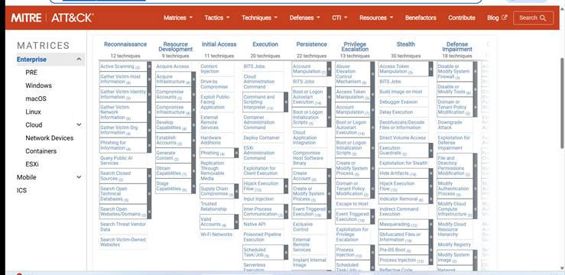
· Poweshell : https://attack.mitre.org/techniques/T1059/001/
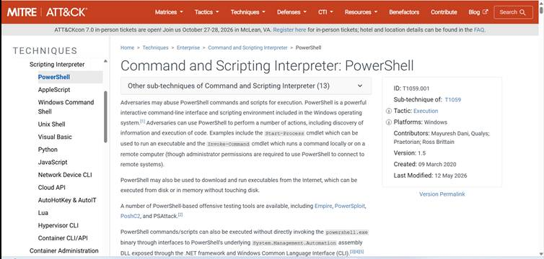
· MITRE ATT&CK Navigator: https://documentation.wazuh.com/current/getting-started/use-cases/threat-hunting.html?gad_source=1&gad_campaignid=24227590513&gbraid=0AAAAADOevajBN3rnOC9bhxwu55m2A0FuU&gclid=CjwKCAjwtp7VBhBjEiwAJfpV-5uYRFrbo5SL-HbSMYFg9Z0eFibIObOzsdvM08m_Ipp0ZJ4rybZfDBoCKJcQAvD_BwE

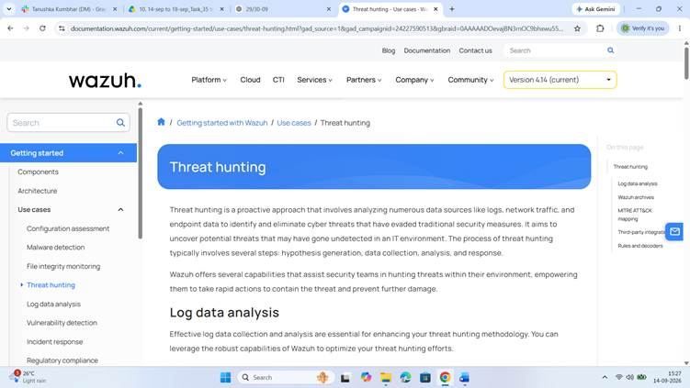
· APT29 : https://attack.mitre.org/groups/G0016/
